Name:Bhagavathy M

Reg.No:2019504012

WATER LEVEL MONITORING SYSTEM USING ULTRASONIC SENSOR:

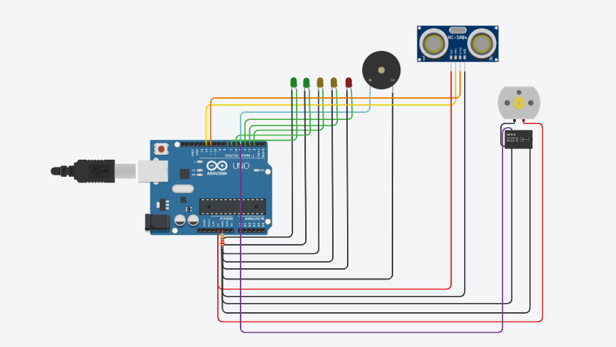

CODE:
int trig=12;
int echo=11;
long distance;
int duration;
void setup()
{
pinMode(2, OUTPUT);
pinMode(3, OUTPUT);
pinMode(4, OUTPUT);
pinMode(5, OUTPUT);
pinMode(6, OUTPUT);
pinMode(7, OUTPUT);
pinMode(12, OUTPUT);
pinMode(11, INPUT);
}

void loop()
{
digitalWrite(12,HIGH);
digitalWrite(12,LOW);
duration=pulseIn(echo,HIGH);
distance=duration*(0.034/2);
if(distance<100)
{
digitalWrite(7,HIGH);
}
else
{
digitalWrite(7,LOW);
}
if(distance<75)
{
digitalWrite(6,HIGH);
}
else
{
digitalWrite(6,LOW);
}
if(distance<60)
{
digitalWrite(2,HIGH);
}
else
{
digitalWrite(2,LOW);
}
if(distance<45)
{
digitalWrite(3,HIGH);
}
else
{
digitalWrite(3,LOW);
}
if(distance<30)
{
digitalWrite(4,HIGH);
}
else
{
digitalWrite(4,LOW);
}
if(distance<15)
{
digitalWrite(5,HIGH);
}
else
{
digitalWrite(5,LOW);
}
}

